COA LABSHEET – 7

Name – Sappa Saran (AM.EN.U4CSE18249)

1. Translate the following‘C’ code into MIPS code.

/\* Loop counter variable declaration and initialization\*/

int n = 1;

/\* Loop condition \*/

while(n <= 10) {

/\* Body of loop \*/

printf("%d ", n);

/\* Update loop counter variable \*/

n++;

}

Ans.

Solution

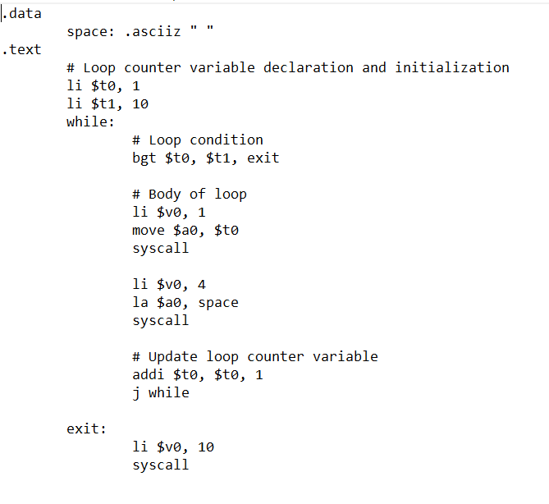

Output



1. Write a MIPS code which will check whether a number is prime number or not.

Ans.

Solution

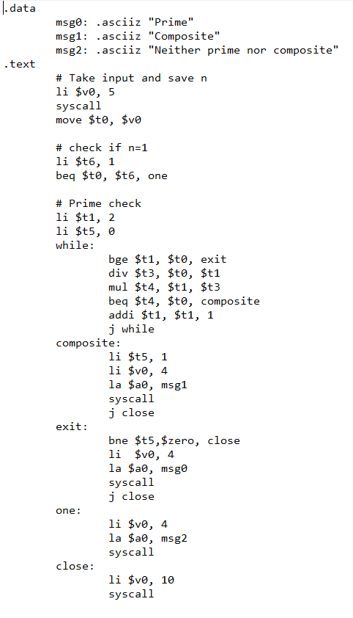

Output

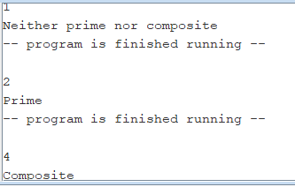

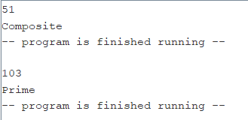

1. Write a MIPS code which will count the prime numbers between 10 and 25.

Ans.

Solution

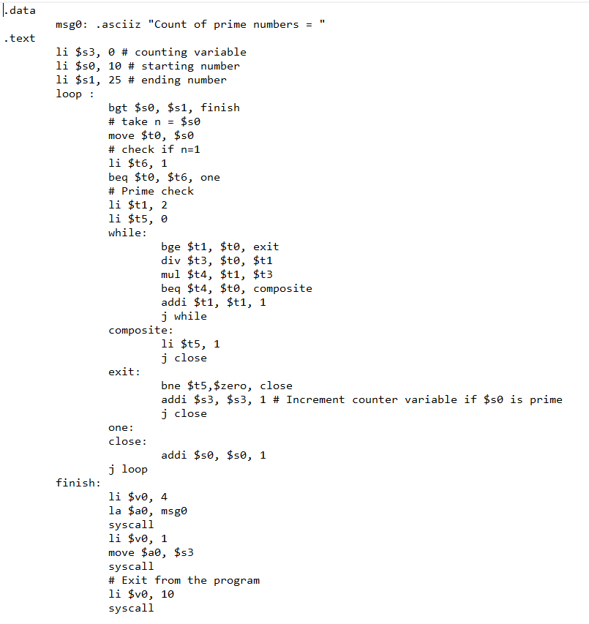

Output



1. Program to check whether the given number is Buzz Number or not.

A number is said to be Buzz Number if it ends with 7 OR is divisible by 7.

The task is to check whether the given number is buzz number or not.

Ans.

Solution

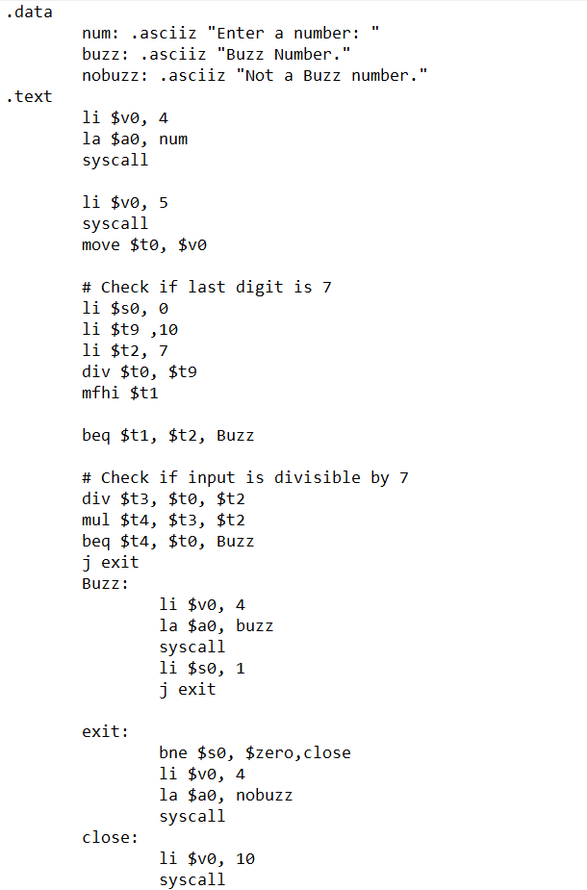

Output:

